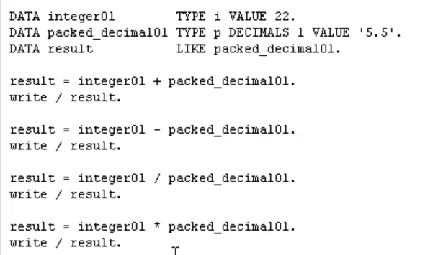

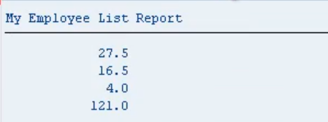

All very simple. conversion rules, arithmetic, you also have the option of using some other statements called ADD, SUBTRACT, DIVIDE, and MULTIPLY.

Now the syntax for these is a little bit different, into a comment, is we can say ADD 8 to and then 8 would contain, let's have a look in this case, 22 plus, that's 27.5 plus 8 would be 35.5.

